Online Shopping



Problem Solving with Programming

Computer Science & Engineering

By

Roll.No : 2103A51253 Name: Saipallavi

Roll.No:2105A41120 Name: Shivasai Prasad

Roll.No: 2103A51105 Name: Ramya Chowdary

Roll.No: 2103A51106 Name: Rahul Rao

Under the Guidance of

Dr.MOHAMMED ALI SHAIK
Assisstanr Professor,School of CSE&AI

Submitted to



PSP-PROJECT

TOPIC- Online Shopping

SECTION-D1(BATCH-11)

CONTENTS | Pg.no
- ABSTRACT  - PROJECT REQUIRMENTS  - PROJECT DOCUMENTATION  - CODE  - OUTPUTS | 3  4  5-6  18-29  30-33

Online Shopping

ABSTRACT:

SR e-Shopping



This project is a web based shopping system for an existing shop. The project objective is to deliver the online shopping application into android platform. This project is an attempt to provide the advantages of online shopping to customers of a real shop. Users will be able to purchase laptops, Mobile, Electronic Items, Foot Wear. Users will be able to add items. Users will be able to reduce the quantity or delete the item. Users will be able to print the bill. Approach Firstly a menu will be displayed to the customer. After the selection, all the products with their prices will be displayed. Then the customer will select the products and chooses the quantity. The customer will be able to increase or decrease the number of items. This process continues until the shopping is completed. Whenever the customer completes his shopping, the items, quantity, cost, and finally the total amount to be paid are displayed on the screen along with discount provided. The main goal of this program is to make shopping easier for the customers.

PROJECT REQUIREMENTS:
HARDWARE:
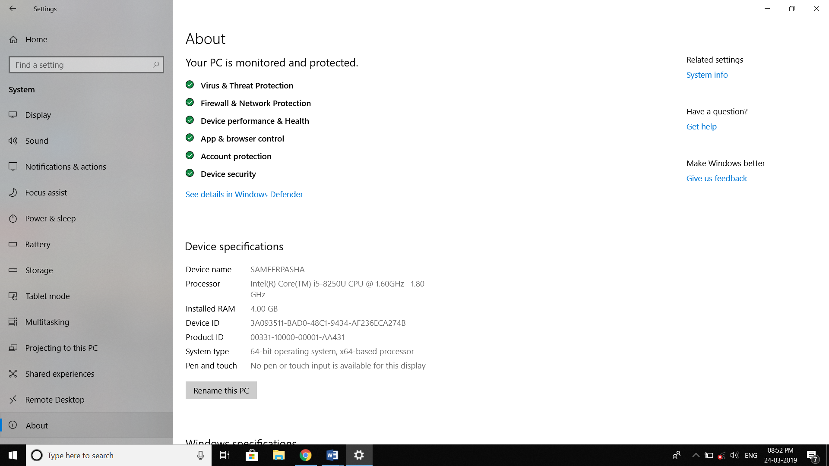

SOFTWARE: DEV C++

+

Dev-C++ is a free full-featured integrated development environment distributed under the GNU General Public License for programming in C and C++. It is written in Delphi. It is bundled with, and uses, the MinGW or TDM-GCC 64bit port of the GCC as its compiler.

Written in: Object Pascal
Developer(s): Bloodshed Software until 2005, Orwell (Johan Mes) since 2011
License: GNU General Public License
Stable release: 5.11 / April 27, 2015; 3 years ago
Operating system: Microsoft Windows, Linux (alpha only)
Project Documentation:

In this code we have used functions and structures.

Functions:

- There several advantages of using functions in our code.
- It enhances the readability of a program.
- Using functions in our code made easy to understand.
- It reduces the complexity of a program and gives it a modular structure.
- By implementing functions and procedures in this program, the programmer reduces coding time and debugging time, thereby reducing the overall development time.

Functions Used In project:

When 1 is pressed these functions are executed

- ele_item():It displays the electronic items available to buy. In this function we can add desired electronic items and desired number of product to the cart.
- book():It displays the books available to buy. In this function we can add desired books and desired number of product to the cart.
- shoe():It displays the shoes available to buy. In this function we can add desired shoes and desired number of product to the cart.
When 2 is pressed the products added to the cart are displayed

- displaye():Displays electronic products added to cart.
- displayb():Displays books added to cart.
- displays():Displays shoes added to cart.
When 3 is pressed any product added to the cart can be deleted

- delete_elec():Deletes desired electronic product. It asks to enter product ID for deletion.
- delete_books():Deletes desired books. It asks to enter product ID for deletion.
- delete_shoes():Deletes desired shoes. It asks to enter product ID for deletion.

When 4 is pressed the number of any product added to the cart can be changed.

- change():It displays all the products in the cart, asks the product id that wants to changed. Then it asks the number of products you wish to add to cart.
When 5 is pressed the Products added to the cart will be billed
- bill():It bills the products added to cart. It asks for
- Name of the customer.
- Phone number.
- Address.
Then it shows the products billed along with total amount to be paid.
Structures:
- It combines datatypes of different kinds.
- Structures are used to represent a record.
Structures used in this project:

- electronic_items;
- book;
- shoes;
- electronic_cart;
- book_cart;
- shoes_cart;

Online Shopping
Code:

#include<stdio.h>
#include<string.h>
#include<stdlib.h>
void ele_item();
void book();
void shoe();
void delete_elec();
void delete_books();
void delete_shoes();
void change();
void bill();
int i,n,eid,ei,ne,bid,bi,nb,sid,si,ns,delid,pos=0,chanid=0,j,id,total,totale,totalb,totals,hs_no;
long long int ph_no;
char ech,bch,sch,ch,name[50],adress_state[50],adress_district[50],adress_street[50],adress_city[50];
struct elctronic_items
{
int id;
char item_name[50];
char cpny_name[50];
int price;
int rating;
};
struct elctronic_cart
{
int id;
char item_name[50];
int price;
int no_items;
}ec[10];
struct books_cart
{
int id;
char item_name[50];
int price;
int no_items;
}bc[10];
struct shoes_cart
{
int id;
char brand[50];
int price;
int no_items;
}sc[10];
struct books
{
int id;
char item_name[50];
char author_name[50];
int price;
int rating;
};
struct shoes{
int id;
char brand[50];
int price;
int rating;
};
main()
{
printf("-------------------------------*****Welcome to SR Online Shopping*****---------------------------------------------- ");
int n,ch,ic,p;
char c;
do{
printf("\n\n\n1.Display all kind of items available to buy\n2.Display the total no.of items added\n3.Delet any item selected\n4.Change the quantity of any item selected\n5.Bill the items selected\n");
printf("\nenter yor choice:");
scanf("%d",&ch);
switch(ch)
{
case 1:printf("\n1.Electronic Items\n");
printf("2.Books\n");
printf("3.Shoes\n");
printf("choose the kind of item you want to buy:");
scanf("%d",&ic);
switch(ic)
{
case 1:printf("Id\tItem\t\tCompany\t\tPrice\t\tRating\n");
ele_item();
break;
case 2:printf("Id\tName\t\t\tAuthor Name\t\tPrice\t\tRating\n");
book();
break;
case 3:printf("Id\tBrand\t\tPrice\tRating\n");
shoe();
}
break;
case 2:if(ec[0].id!=0)
{
printf("---------------electronic items----------------------\n");
printf("Id\tName\t\tprice\tNo.of items\n");
displaye(ec,ei);
}
if(bc[0].id!=0)
{
printf("---------------Books----------------------\n");
printf("Id\tName\t\tprice\tNo.of items\n");
displayb(bc,bi);
}
if(sc[0].id!=0)
{
printf("---------------Shoes----------------------\n");
printf("Id\tName\t\tprice\tNo.of items\n");
displays(sc,si);
}
break;
case 3:if(ec[0].id!=0)
{
printf("---------------electronic items----------------------\n");
printf("Id\tName\t\tprice\tNo.of items\n");
displaye(ec,ei);
}
if(bc[0].id!=0)
{
printf("---------------Books----------------------\n");
printf("Id\tName\t\tprice\tNo.of items\n");
displayb(bc,bi);
}
if(sc[0].id!=0)
{
printf("---------------Shoes----------------------\n");
printf("Id\tName\t\tprice\tNo.of items\n");
displays(sc,si);
}
do
{
printf("Enter the id of the prodect you wish to delete:");
scanf("%d",&delid);
id=delid/100;
switch(id)
{
case 1:delete_elec(delid,ei);
break;
case 2:delete_books(delid,bi);
break;
case 3:delete_shoes(delid,si);
break;
}
printf("\nEnter d to delete more item:");
scanf(" %c",&ch);
}while(ch=='d');
break;
case 4:if(ec[0].id!=0)
{
printf("---------------electronic items----------------------\n");
printf("Id\tName\t\tprice\tNo.of items\n");
displaye(ec,ei);
}
if(bc[0].id!=0)
{
printf("---------------Books----------------------\n");
printf("Id\tName\t\tprice\tNo.of items\n");
displayb(bc,bi);
}
if(sc[0].id!=0)
{
printf("---------------Shoes----------------------\n");
printf("Id\tName\t\tprice\tNo.of items\n");
displays(sc,si);
}
change();
break;
case 5:bill();
exit(0);
break;
}
printf("press y to display options:");
scanf(" %c",&c);
}while(c=='y');
}
void ele_item()
{
struct elctronic_items e1={101,"Laptop","HP",65990,8};
struct elctronic_items e2={102,"Mobile","Samsung",20300,9};
struct elctronic_items e3={103,"Oven","Philips",7999,10};
struct elctronic_items e4={104,"Camera","Canon",75000,7};
struct elctronic_items e5={105,"Airpods","Apple",29999,9};
printf("%d\t%s\t\t%s\t\t%d\t\t%d\n",e1.id,e1.item_name,e1.cpny_name,e1.price,e1.rating);
printf("%d\t%s\t\t%s\t\t%d\t\t%d\n",e2.id,e2.item_name,e2.cpny_name,e2.price,e2.rating);
printf("%d\t%s\t\t%s\t\t%d\t\t%d\n",e3.id,e3.item_name,e3.cpny_name,e3.price,e3.rating);
printf("%d\t%s\t\t%s\t\t%d\t\t%d\n",e4.id,e4.item_name,e4.cpny_name,e4.price,e4.rating);
printf("%d\t%s\t\t%s\t\t%d\t\t%d\n",e5.id,e5.item_name,e5.cpny_name,e5.price,e5.rating);
do{
printf("Enter the Id of the product you want to add to cart:");
scanf("%d",&eid);
switch(eid)
{
case 101:printf("Enter The no.of %s you want to add:",e1.item_name);
scanf("%d",&ne);
ec[ei].id=e1.id;
strcpy(ec[ei].item_name,e1.item_name);
ec[ei].price=e1.price;
ec[ei].no_items=ne;
ei++;
break;
case 102:printf("Enter The no.of %s you want to add:",e2.item_name);
scanf("%d",&ne);
ec[ei].id=e2.id;
strcpy(ec[ei].item_name,e2.item_name);
ec[ei].price=e2.price;
ec[ei].no_items=ne;
ei++;
break;
case 103:printf("Enter The no.of %s you want to add:",e3.item_name);
scanf("%d",&ne);
ec[ei].id=e3.id;
strcpy(ec[ei].item_name,e3.item_name);
ec[ei].price=e3.price;
ec[ei].no_items=ne;
ei++;
break;
case 104:printf("Enter The no.of %s you want to add:",e4.item_name);
scanf("%d",&ne);
ec[ei].id=e4.id;
strcpy(ec[ei].item_name,e4.item_name);
ec[ei].price=e4.price;
ec[ei].no_items=ne;
ei++;
break;
case 105:printf("Enter The no.of %s you want to add:",e5.item_name);
scanf("%d",&ne);
ec[ei].id=e5.id;
strcpy(ec[ei].item_name,e5.item_name);
ec[ei].price=e5.price;
ec[ei].no_items=ne;
ei++;
break;
}
printf("Press e if you want add anymore products from electronics:");
scanf(" %c",&ech);
}while(ech=='e');
}
void book()
{
struct books b1={201,"Alchemist","Paulo Coelho",227,7};
struct books b2={202,"Wings Of Fire","Abdul Kalam",400,9};
struct books b3={203,"Ikigai ","Hector Garciar",356,8};
struct books b4={204,"You Can ","George Adams",112,7};
struct books b5={205,"Gone Girl","Gillian Flynn",189,9};
printf("%d\t%s\t\t\t%s\t\t\t%d\t\t\t%d\n",b1.id,b1.item_name,b1.author_name,b1.price,b1.rating);
printf("%d\t%s\t\t\t%s\t\t\t%d\t\t\t%d\n",b2.id,b2.item_name,b2.author_name,b2.price,b2.rating);
printf("%d\t%s\t\t\t%s\t\t\t%d\t\t\t%d\n",b3.id,b3.item_name,b3.author_name,b3.price,b3.rating);
printf("%d\t%s\t\t\t%s\t\t\t%d\t\t\t%d\n",b4.id,b4.item_name,b4.author_name,b4.price,b4.rating);
printf("%d\t%s\t\t\t%s\t\t\t%d\t\t\t%d\n",b5.id,b5.item_name,b5.author_name,b5.price,b5.rating);
do{
printf("Enter the Id of the product you want to add to cart:");
scanf("%d",&bid);
switch(bid)
{
case 201:printf("Enter The no.of %s you want to add:",b1.item_name);
scanf("%d",&nb);
bc[ei].id=b1.id;
strcpy(bc[bi].item_name,b1.item_name);
bc[bi].price=b1.price;
bc[bi].no_items=nb;
bi++;
break;
case 202:printf("Enter The no.of %s you want to add:",b2.item_name);
scanf("%d",&nb);
bc[bi].id=b2.id;
strcpy(bc[bi].item_name,b2.item_name);
bc[bi].price=b2.price;
bc[bi].no_items=nb;
bi++;
break;
case 203:printf("Enter The no.of %s you want to add:",b3.item_name);
scanf("%d",&nb);
bc[bi].id=b3.id;
strcpy(bc[bi].item_name,b3.item_name);
bc[bi].price=b3.price;
bc[bi].no_items=nb;
bi++;
break;
case 204:printf("Enter The no.of %s you want to add:",b4.item_name);
scanf("%d",&nb);
bc[bi].id=b4.id;
strcpy(bc[bi].item_name,b4.item_name);
bc[bi].price=b4.price;
bc[bi].no_items=nb;
bi++;
break;
case 205:printf("Enter The no.of %s you want to add:",b5.item_name);
scanf("%d",&nb);
bc[bi].id=b5.id;
strcpy(bc[bi].item_name,b5.item_name);
bc[bi].price=b5.price;
bc[bi].no_items=nb;
bi++;
break;
}
printf("Press b if you want add anymore products from books:");
scanf(" %c",&bch);
}while(bch=='b');
}
void shoe()
{
struct shoes s1={301,"Nike ",5698,7};
struct shoes s2={302,"Adidas ",5999,8};
struct shoes s3={303,"Puma ",2999,9};
struct shoes s4={304,"Reebok ",3998,6};
struct shoes s5={305,"SKECHERS",3985,9};
printf("%d\t%s\t%d\t%d\n",s1.id,s1.brand,s1.price,s1.rating);
printf("%d\t%s\t%d\t%d\n",s2.id,s2.brand,s2.price,s2.rating);
printf("%d\t%s\t%d\t%d\n",s3.id,s3.brand,s3.price,s3.rating);
printf("%d\t%s\t%d\t%d\n",s4.id,s4.brand,s4.price,s4.rating);
printf("%d\t%s\t%d\t%d\n",s5.id,s5.brand,s5.price,s5.rating);
do{
printf("Enter the Id of the product you want to add to cart:");
scanf("%d",&sid);
switch(sid)
{
case 301:printf("Enter The no.of %s shoes you want to add:",s1.brand);
scanf("%d",&ns);
sc[si].id=s1.id;
strcpy(sc[si].brand,s1.brand);
sc[si].price=s1.price;
sc[si].no_items=ns;
si++;
break;
case 302:printf("Enter The no.of %s shoes you want to add:",s2.brand);
scanf("%d",&ns);
sc[si].id=s2.id;
strcpy(sc[si].brand,s2.brand);
sc[si].price=s2.price;
sc[si].no_items=ns;
si++;
break;
case 303:printf("Enter The no.of %s shoes you want to add:",s3.brand);
scanf("%d",&ns);
sc[si].id=s3.id;
strcpy(sc[si].brand,s3.brand);
sc[si].price=s3.price;
sc[si].no_items=ns;
si++;
break;
case 304:printf("Enter The no.of %s shoes you want to add:",s4.brand);
scanf("%d",&ns);
sc[si].id=s4.id;
strcpy(sc[si].brand,s4.brand);
sc[si].price=s4.price;
sc[si].no_items=ns;
si++;
break;
case 305:printf("Enter The no.of %s shoes you want to add:",s5.brand);
scanf("%d",&ns);
sc[si].id=s5.id;
strcpy(sc[si].brand,s5.brand);
sc[si].price=s5.price;
sc[si].no_items=ns;
si++;
break;
}
printf("Press s if you want add anymore products from shoess:");
scanf(" %c",&sch);
}while(sch=='s');
}
displaye(struct elctronic_cart ec[],int(n))
{
for(i=0;i<n;i++)
printf("%d\t%s\t\t%d\t%d\n",ec[i].id,ec[i].item_name,ec[i].price,ec[i].no_items);
}
displayb(struct books_cart bc[],int(n))
{
for(i=0;i<n;i++)
printf("%d\t%s\t%d\t%d\n",bc[i].id,bc[i].item_name,bc[i].price,bc[i].no_items);
}
displays(struct shoes_cart sc[],int(n))
{
for(i=0;i<n;i++)
printf("%d\t%s\t%d\t%d\n",sc[i].id,sc[i].brand,sc[i].price,sc[i].no_items);
}
void change()
{
do
{
printf("Enter the Id of the product you wish to change the quantity:");
scanf("%d",&chanid);
for(i=0;i<ei;i++)
{
if(chanid==ec[i].id)
{
printf("Enter the no.of quatities you want:");
scanf("%d",&ec[i].no_items);
break;
}
}
pos=0;
for(i=0;i<bi;i++)
{
if(chanid==bc[i].id)
{
printf("Enter the no.of quatities you want:");
scanf("%d",&bc[i].no_items);
break;
}
}
pos=0;
for(i=0;i<si;i++)
{
if(chanid==sc[i].id)
{
printf("Enter the no.of quatities you want:");
scanf("%d",&sc[i].no_items);
break;
}
}
printf("------------------------------Product Quantity changed Succesfully---------------------------------------\n\n");
printf("Enter c to change the quantity of more items:");
scanf(" %c",&ch);
}while(ch=='c');
}
void delete_elec(delid,n)
{
pos=0;
for(i=0;i<n;i++)
{
pos++;
if(ec[i].id==delid)
{
for(j=pos-1;j<n;j++)
ec[j]=ec[j+1];
ei--;
}
}
printf("-------------------------------------------Item deleted Sucessfully-----------------------------------------------");
}
void delete_books(delid,n)
{
pos=0;
for(i=0;i<n;i++)
{
pos++;
if(bc[i].id==delid)
{
for(j=pos-1;j<n;j++)
bc[j]=bc[j+1];
bi--;
}
}
printf("-------------------------------------------Item deleted Sucessfully-----------------------------------------------");
}
void delete_shoes(delid,n)
{
pos=0;
for(i=0;i<n;i++)
{
pos++;
if(sc[i].id==delid)
{
for(j=pos-1;j<n;j++)
sc[j]=sc[j+1];
si--;
}
}
printf("-------------------------------------------Item deleted Sucessfully-----------------------------------------------");
}
void bill()
{
printf("Please Enter your Name:");
scanf("%s",name);
printf("Enter Phone Number:");
scanf("%lld",&ph_no);
printf("ENTER ADDRESS");
printf("\nHouse Number:");
scanf("%d",&hs_no);
printf("Street:");
scanf("%s",adress_street);
printf("Town/City:");
scanf("%s",adress_city);
printf("District:");
scanf("%s",adress_district);
printf("State:");
scanf("%s",adress_state);
if(ec[0].id!=0)
{
printf("\n-------------------------------------Electronic Items------------------------------------\n");
for(i=0;i<ei;i++)
{
printf("ID:%d\nItem_Name:%s\nPrice:%d\nNo_Items:%d\n",ec[i].id,ec[i].item_name,ec[i].price,ec[i].no_items);
totale+=ec[i].price*ec[i].no_items;
}
}
if(totale!=0)
{
printf("---------------------------------------------------------------\n");
printf("Total Electronics Bill=%d\n",totale);
printf("---------------------------------------------------------------\n");
}
if(bc[0].id!=0)
{
printf("---------------------------------Books----------------------------------------------------\n");
for(i=0;i<bi;i++)
{
printf("ID:%d\nBook_Name:%s\nPrice:%d\nNo_Items:%d\n",bc[i].id,bc[i].item_name,bc[i].price,bc[i].no_items);
totalb+=bc[i].price*bc[i].no_items;
}
}
if(totalb!=0)
{
printf("---------------------------------------------------------------\n");
printf("Total Books Bill=%d\n",totalb);
printf("---------------------------------------------------------------\n");
}
if(sc[0].id!=0)
{
printf("----------------------------------------Shoes----------------------------------------------\n");
for(i=0;i<si;i++)
{
printf("ID:%d\nBrand_Name:%s\nPrice:%d\nNo_Items:%d\n",sc[i].id,sc[i].brand,sc[i].price,sc[i].no_items);
totals+=sc[i].price*sc[i].no_items;
}
}

if(totals!=0)
{
printf("---------------------------------------------------------------\n");
printf("Total Shoes Bill=%d\n",totals);
printf("---------------------------------------------------------------\n");
}
total=totale+totalb+totals;
printf("---------------------------------------------------------------\n");
printf("TOTAL BILL=%d\n",total);
printf("----------------------------------------------------------------\n");
printf("------------------***Thank You For Buying %s***----------------",name);
}

OUTPUTs:

Displaying Available Items and Adding products to cart:

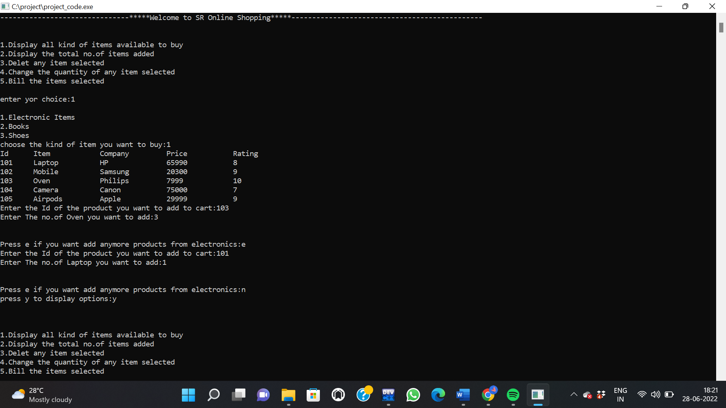

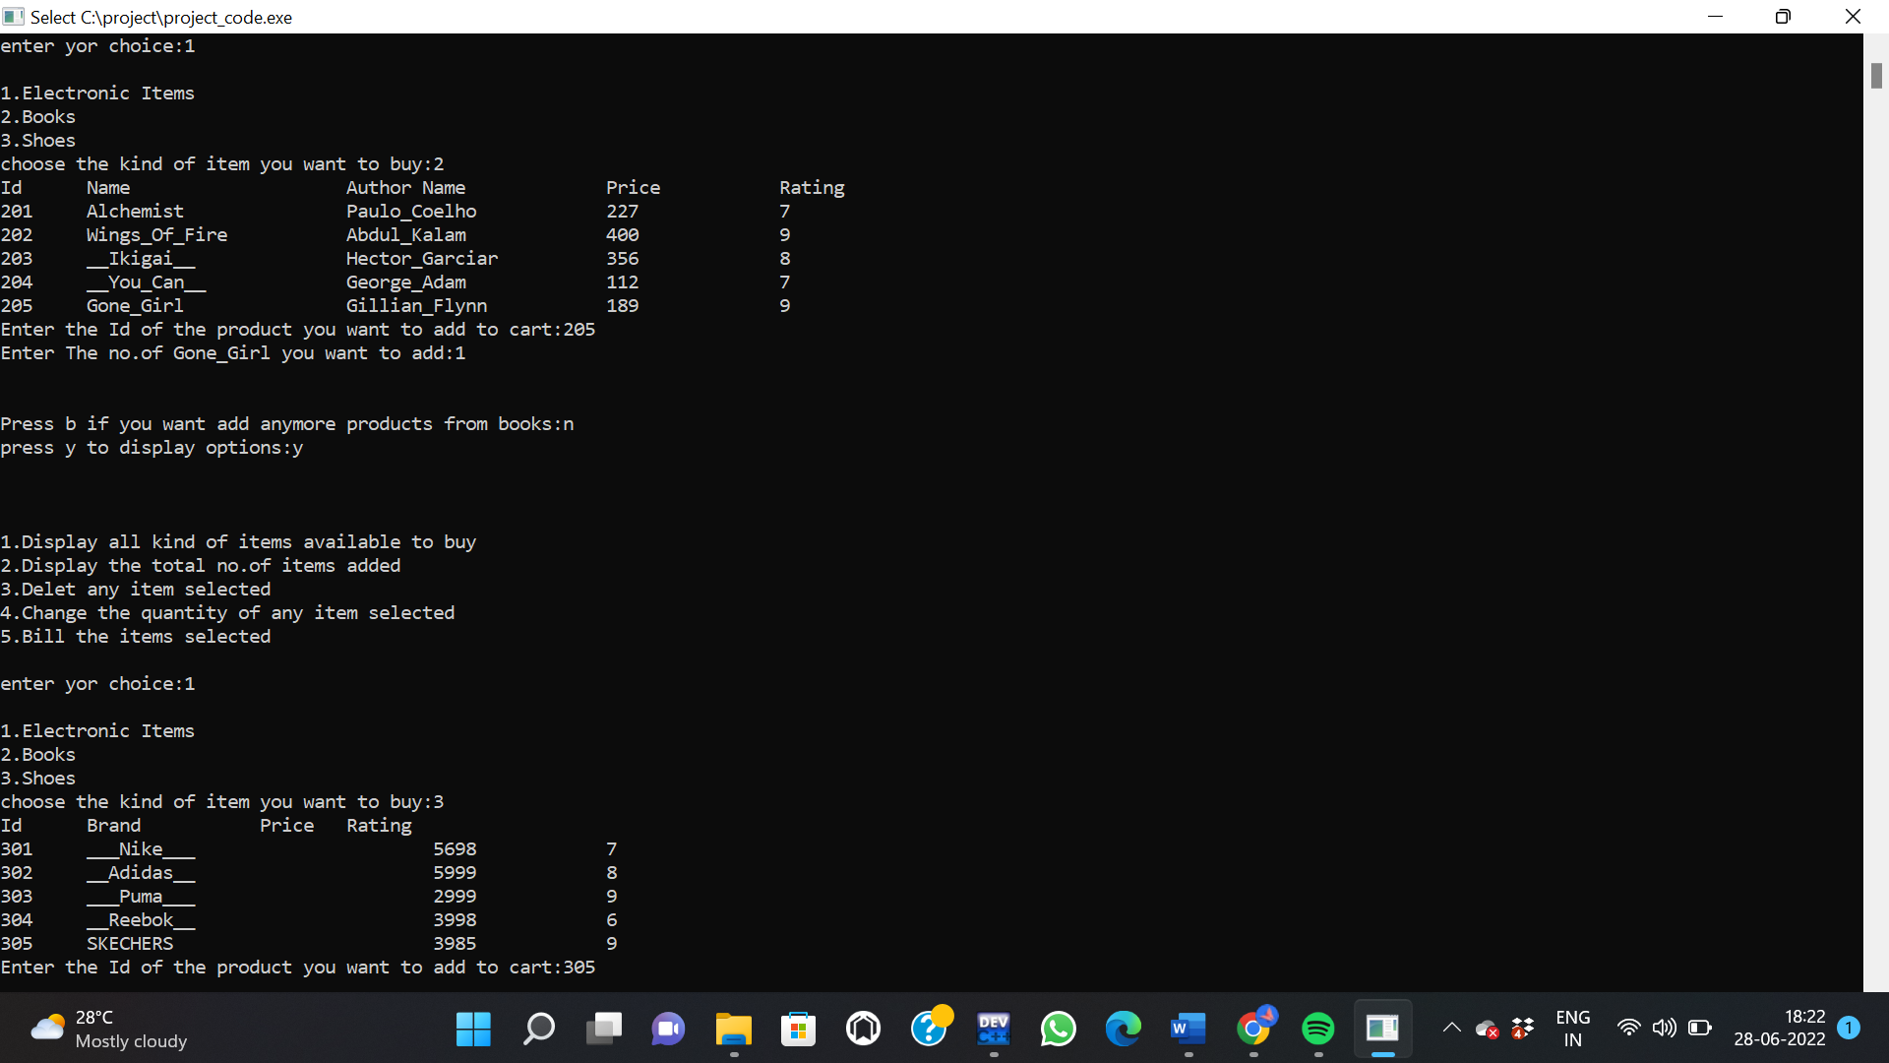
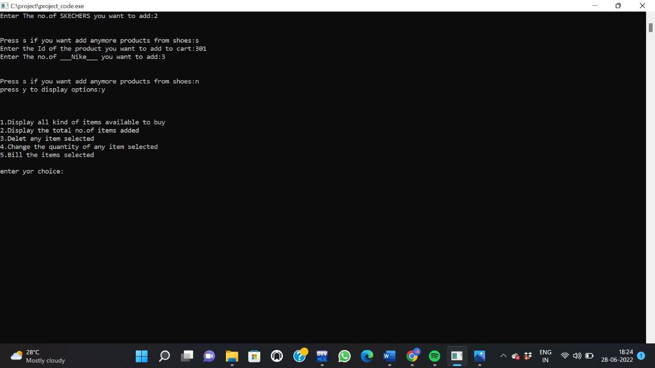

Displaying products in cart:

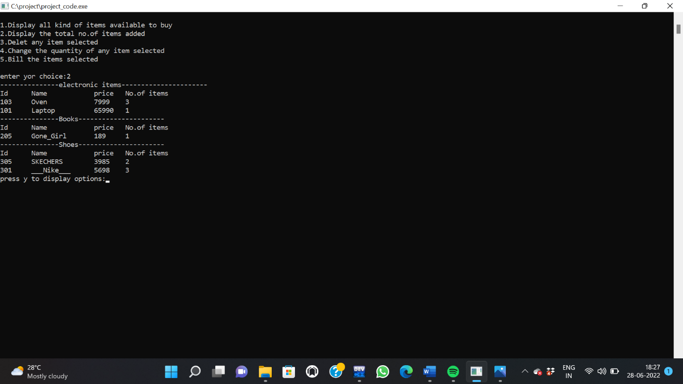

Deleting desired product in cart:

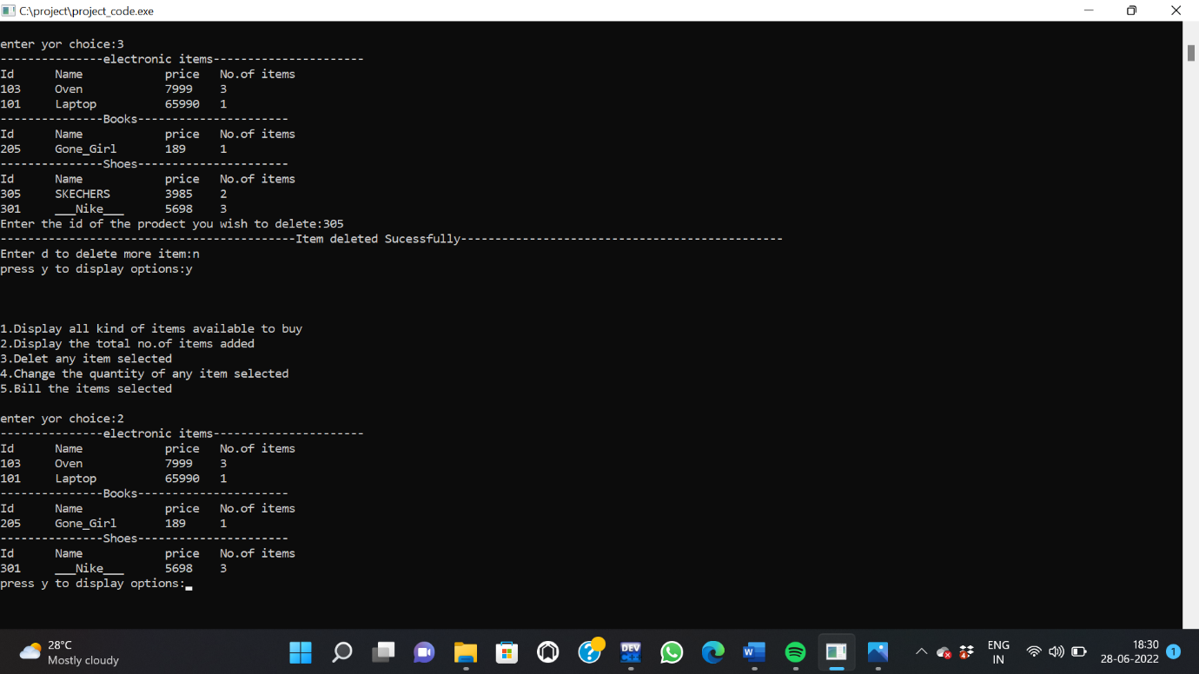

Changing number of desired product in cart:

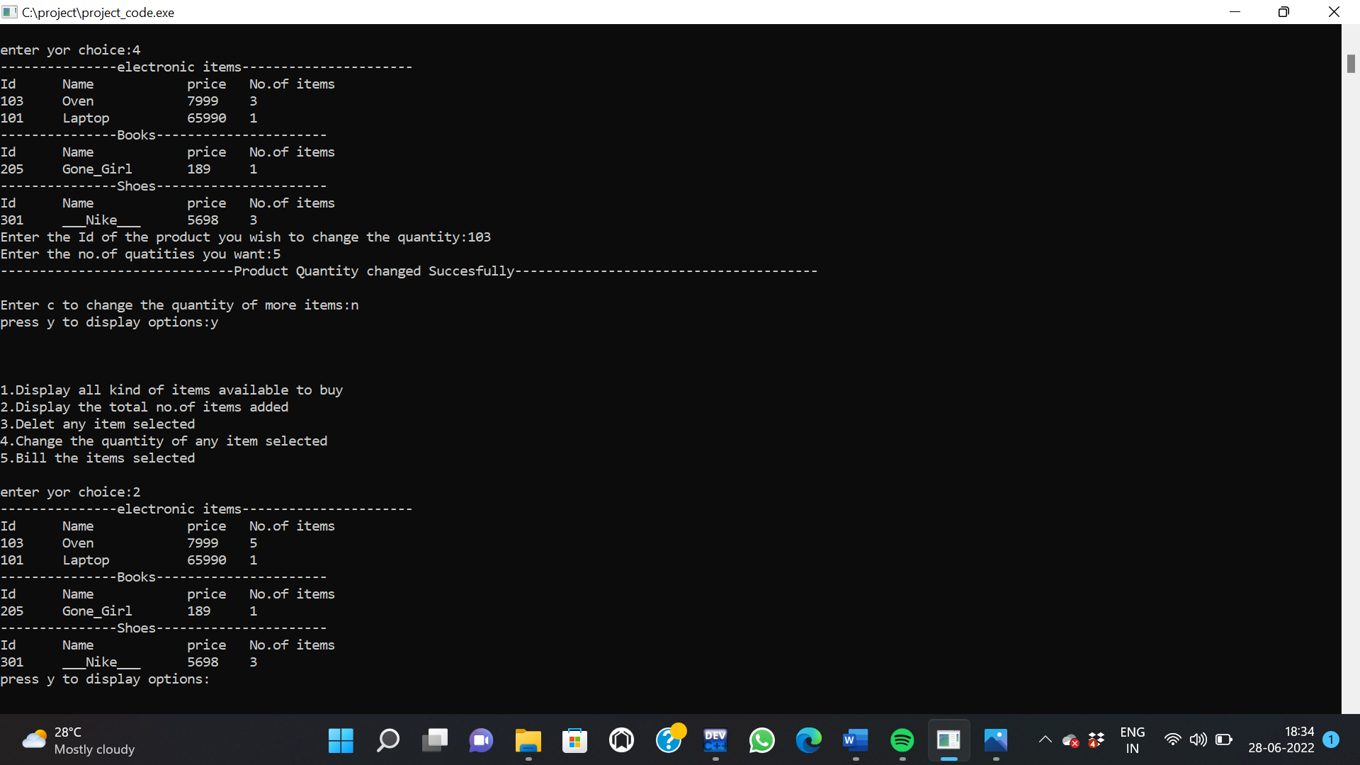

Billing Products:

